|  | 2814ICT/7003ICT – Data Management / Database Design  School of Information & Communication Technology |
| --- | --- |

**Lab 3.2 Exercise**

**1. Writing the relational database schema**

For the ERD below, write the relational database schema.

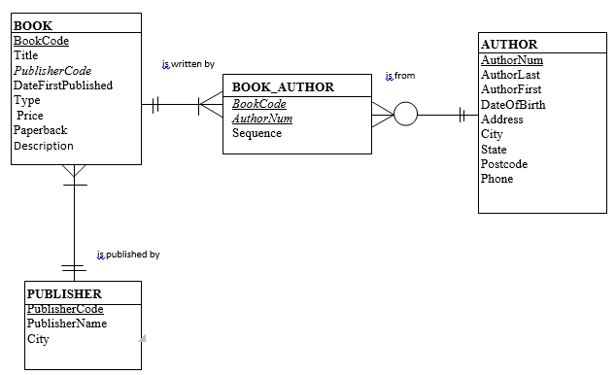

**Your answer:**

# **Relational Database Schema**

(Complete the table below)

| **Table Name** | **Field** | **Type** | **Description** |
| --- | --- | --- | --- |
| Book | BookCode | VARCHAR(6) | PRIMARY KEY  NOT NULL |
|  | Title | VARCHAR(40) |  |
|  | PublisherCode | VARCHAR(3) | FOREIGN KEY REFERENCES PUBLISHER(PublisherCode) |
|  | DateFirstPublished | DATE | Format:DD-MM-YYYY |
|  | Type | VARCHAR(3) |  |
|  | Price | DOUBLE |  |
|  | Paperback | CHAR(1) |  |
|  | Description | VARCHAR(30) |  |
| Book author | Book code | VARCHAR(6) | PRIMARY KEY  NOT NULL |
|  | AuthorNum | INT(11) | FOREIGN KEY REFERENCES Author(AuthorNum)  PRIMARY KEY |
|  | Sequence | INT |  |
| Author | AuthorNum | INT(11) | PRIMARY KEY  NOT NULL  AUTO_INCREMENT |
|  | AuthorLast | VARCHAR(12) |  |
|  | AuthorFirst | VARCHAR(10) |  |
|  | DateofBirth | DATE | Format:DD-MM-YYYY |
|  | Address | VARCHAR(50) |  |
|  | City | VARCHAR(30) |  |
|  | State | VARCHAR(20) |  |
|  | Postcode | INT(4) |  |
|  | Phone | INT |  |
| Publisher | Publisher Code | VARCHAR(3) | PRIMARY KEY  NOT NULL |
|  | Publisher Name | VARCHAR(10) |  |
|  | City | VARCHAR(30) |  |